**CryptoBeast Whitepaper**

(Updated July 2025)

This whitepaper outlines the vision, technology, and tokenomics of the CryptoBeast project.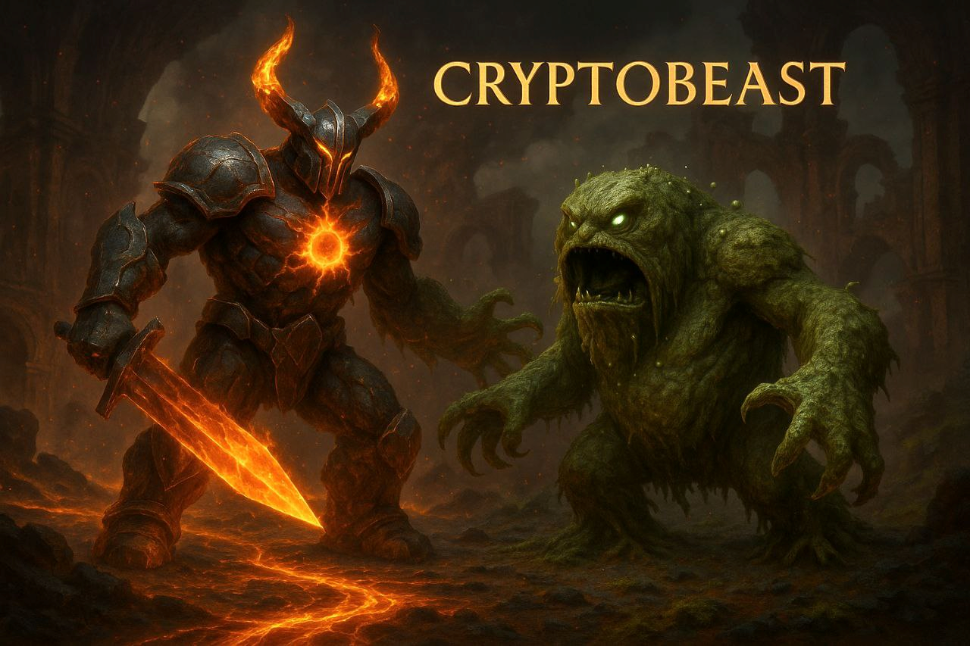

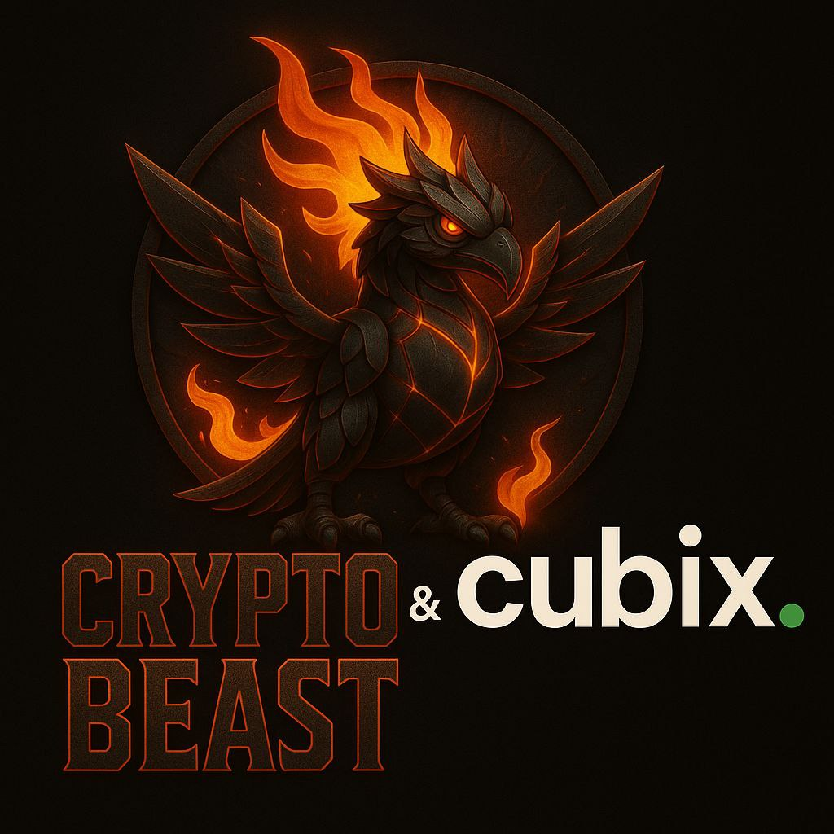

# Table of Contents

1. Introduction

2. Problem Statement

3. Solution Overview

4. Project Description

5. Tokenomics

6. Technical Architecture

7. Smart Contract Security & Audits

8. Token Vesting & Unlock Schedule

9. Roadmap

10. Team

11. Legal Disclaimer

# Introduction

**Welcome to CryptoBeast**  
CryptoBeast is a dynamic, community-driven memecoin designed to unleash the full potential of the crypto space. In an industry often crowded with fleeting trends, CryptoBeast stands out through its commitment to fairness, transparency, and innovation. Our mission is to create more than just a token—a vibrant movement powered by memes, community engagement, and a robust ecosystem integrating NFTs and a beast-themed metaverse.

# Problem Statement

The current cryptocurrency landscape lacks interactive and engaging platforms that seamlessly integrate decentralized finance (DeFi), non-fungible tokens (NFTs), and play-to-earn (P2E) mechanics, limiting user engagement and the potential for innovative, community-driven ecosystems.

# Solution Overview

CryptoBeast aims to provide a unique ecosystem where users can earn, trade, and stake tokens while participating in a beast-themed metaverse.

✅ **Fair Launch** – No private VC deals, no insider advantages.

✅ **Fully Community Driven** – Memes, contests, and governance by the pack.

✅ **Transparent Development** – Regular updates, clear roadmap.

✅ **Marketing Beast Mode** – Aggressive social media campaigns and influencer partnerships.

✅ **Fun, Utility & Growth** – From NFTs to staking, $CBTS has real use-cases.

✅ **Epic Game and Fresh Updates** - Unleashing a thrilling game with constant updates to keep the CryptoBeast World growing wild.

# Project Description

CryptoBeast is an Ethereum-based NFT game that enables players to collect, battle, and evolve unique creatures within a play-to-earn metaverse.

Our mission is to create an immersive ecosystem that seamlessly integrates gaming, tokenomics, and community engagement, rewarding players for their participation and progression.

CryptoBeast has partnered with Cubix, a globally recognized leader in blockchain and gaming development, to bring this vision to life. The development budget consists of an initial investment of $180,000, payable two months after project commencement, followed by eight milestone-based payments of $70,000 each.

# Tokenomics

*Token Name:* CryptoBeast Token (CBTS)

*Total Supply:* 10,000,000,000

*Distribution:*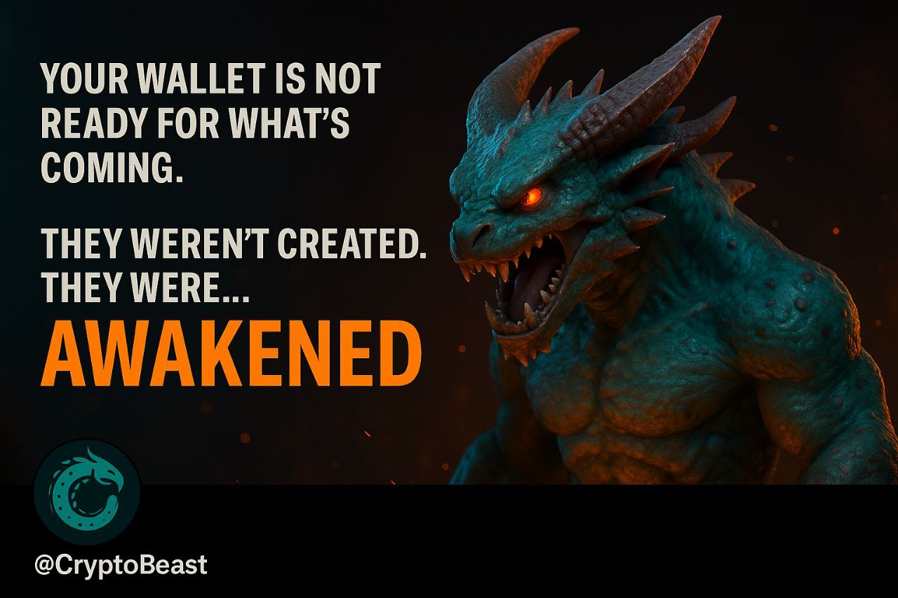

- 40% Presale (across 4 stages)

- 20% Marketing / Community Building

- 20% Admin / Support (locked for 360 days from July 26, 2025)

- 10% Rewards

- 10% Liquidity (details to be finalized)

All unsold tokens during each presale stage will be burned to maintain scarcity and deflationary pressure.

*Presale Details:*

Platform: PinkSale (Ethereum Chain)

Presale Stages: 4 total

Tokens for Presale: 1,000,000,335 CBTS

Rate: 1 ETH = 1,834,863 CBTS

Soft Cap: 150 ETH

Hard Cap: 545 ETH

Start Time: July 24, 2025 - 00:00 UTC

End Time: December 25, 2025 - 01:00 UTC

Contract: 0xDEaa3E2Bb3743C1b1a4691081B0FB964fA173faC

Liquidity: Manual listing (not auto-added)

*Token Utility:*

- In-game currency to purchase NFTs, upgrades, and beast evolutions

- Player reward system for achievements and seasonal events

- Governance: Community will vote on future updates and development paths

- Future: Staking, breeding, and fusion systems planned for Q2 2026

- Admin Tokens: Locked for 720 days from July 26, 2025

- Unsold Tokens: Burned after each presale stage

- Liquidity: Manual listing, lock percentage and duration TBA

# 6. Technical Architecture

# CryptoBeast is built on the Ethereum blockchain using the ERC-20 standard for its CBTS token.

# 7. Smart Contract Security & Audits

# All CryptoBeast smart contracts will be audited by a reputable third-party security firm. The audit will focus on vulnerabilities such as reentrancy, overflow/underflow, and permission access. Audit results will be made publicly available before presale completion.

# 8. Token Vesting & Unlock Schedule

The distribution of tokens from the presale (40% of total supply, 4,000,000,000 CBTS) will occur as follows:

* First Three Presale Stages: Tokens allocated to the first three presale stages will be distributed to participants immediately upon the completion of each respective stage.
* Final Presale Stage: Tokens from the fourth presale stage will be subject to a vesting schedule, with 10% of the allocated tokens released every two weeks following the presale end date (December 25, 2025, 01:00 UTC) until fully distributed.

# 9. Roadmap

**Phase 1: The Awakening (Q2 2025)**  
✅ Project Ideation & Brand Development  
✅ Social Media Setup (X, Telegram, Website)  
✅ Whitepaper Release  
✅ Website Launch  
✅ Smart Contract Development  
✅ Audit Process Initiated

**Phase 2: The Beast Unleashed** **(Q3 2025)**  
🔜 Presale Launch (Fair & Transparent)  
🔜 PancakeSwap Listing  
🔜 Liquidity Locked Announcement  
🔜 Initial CMC & CG Listings  
🔜 Aggressive Meme & Marketing Campaign  
🔜 $CBTS Community Airdrop

**Phase 3: Domination Begins** **(Q4 2025 - Q2 2026)**  
🔜 NFT Collection Release (CryptoBeast-themed)  
🔜 Partnership Announcements, Game Development Milestones  
🔜 CEX Listings Negotiations, NFT Release  
🔜 Staking & Utility Features Rollout  
🔜 Merch Drop – Wear the Beast

**Phase 4: Evolution & Expansion** **(2026)**  
🔜 DAO Implementation – Community Votes  
🔜 Metaverse Integration Exploration, Full Game Launch  
🔜 New Use-Cases & Real-World Partnerships, DAO Integration  
🔜 $CBTS Top 100 CMC Target, Major Listings  
🔜 Long-Term Growth Strategy Refinement

# 10. Team

Our experienced team of developers, blockchain experts, and digital artists is committed to creating an innovative and engaging crypto entertainment ecosystem for CryptoBeast.

# 11. Legal Disclaimer

This whitepaper is provided for informational purposes only and does not constitute an offer, solicitation, or recommendation to purchase or sell shares, securities, or any other financial instruments in CryptoBeast or any related entity.

Participation in the CryptoBeast project, including the purchase of CryptoBeast Tokens (CBTS) or associated NFTs, involves significant risks due to the volatile nature of cryptocurrencies and digital assets.

The value of CBTS and related assets may fluctuate significantly, and investors may lose all or part of their investment. Potential investors should be aware of the tax implications of purchasing, holding, or selling CBTS, as profits may be subject to capital gains or other taxes depending on their jurisdiction.

Cryptocurrency and NFT regulations vary widely across jurisdictions, and it is the responsibility of each investor to ensure compliance with applicable laws and regulations in their region.

CryptoBeast and its affiliates make no guarantees or warranties regarding the future performance, value, or utility of CBTS or any associated products.

All information in this whitepaper is subject to change without notice. Investors are strongly encouraged to conduct thorough independent research and seek professional financial, legal, and tax advice before participating in the CryptoBeast project.

Only invest funds you can afford to lose.

All intellectual property, including images, designs, and branding used in this whitepaper, is the property of CryptoBeast or its licensors and is protected by applicable copyright and trademark laws.

Website: <https://cryptobeastofficial.com>

Telegram: <https://t.me/CryptoBeastOfficial>

Twitter/X: [http://x.com/TheBeastAwakens](https://x.com/TheBeastAwakens)